**A FULL STACK DEVELOPMENT CAPSTONE PROJECT**



FoodBox

*(Source Code)*

* **Version History:**

|  |  |  |
| --- | --- | --- |
| 1. | **Author Name** | Guneet Pal Singh |
| 2. | **Purpose** | Source Code. |
| 3. | **Date** | 09/10/2022 |
| 4. | **Version** | 1.0 |
| 5. | **Contact** | [*guneetpal99@gmail.com*](mailto:guneetpal99@gmail.com) |

Contents.

1. User Flow Chart Diagram 3
2. GitHub Link… 4
3. Database Design… 4
4. Folder Structure… 6
5. Project Files… 11

# User Flow Chart Diagram.

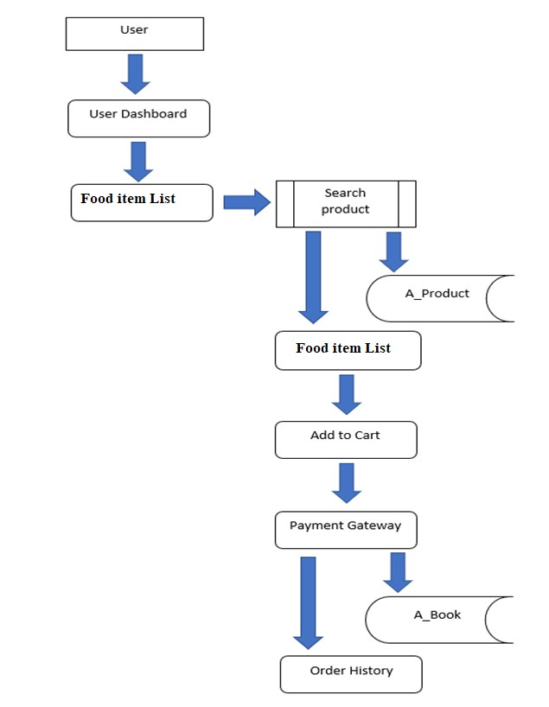

1. ***GitHub Link.***

|  |  |
| --- | --- |
| **Repository Name.** | FoodBox-Capstone-Project |
| **GitHub Link.** | **https://github.com/GuneetPalSingh/Foodbox_Capstone_Project/tree/master** |

1. ***Database Design.***

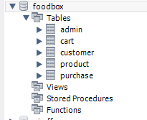

Data Result Set:

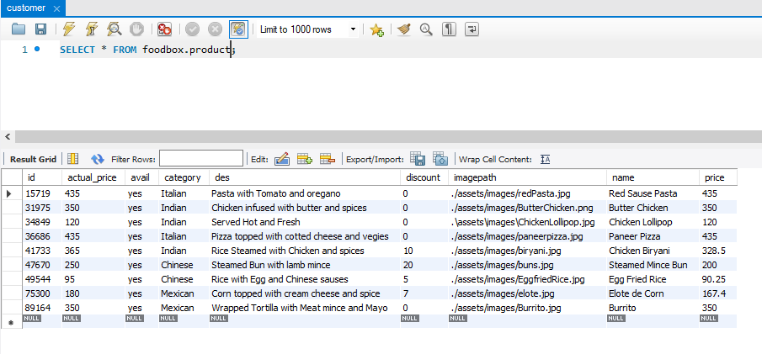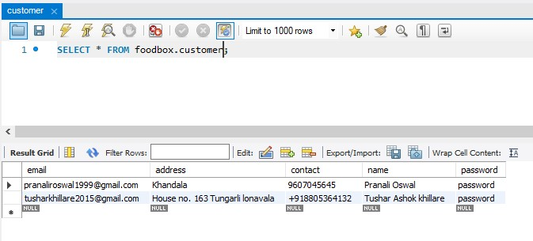

1. ***Folder Structure.***

**(Back End Development)**

Spring Project Structure

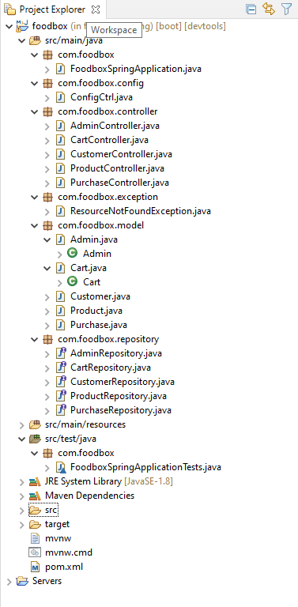

Pom.xml

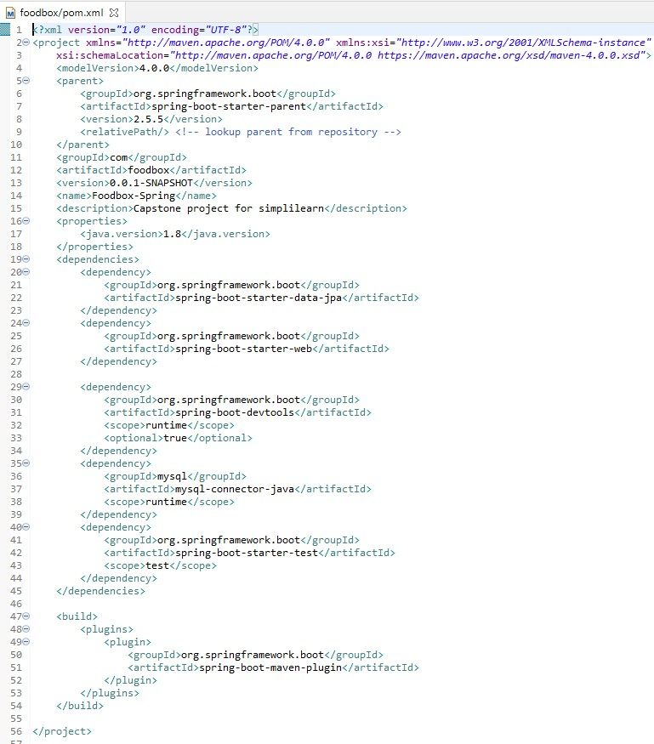

FoodSpringApplication.Java

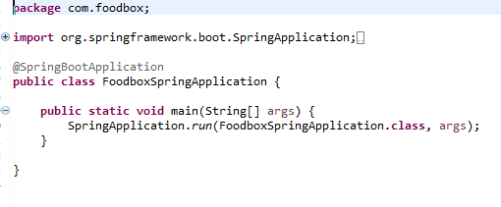

FoodboxSpringApplicationTests.Java

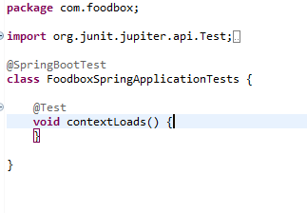

Rest of the files are present in the given GitHub link kindly refer this…

## <https://github.com/tuskhillare/FoodBox-Capstone-Project.git>

Spring Output:

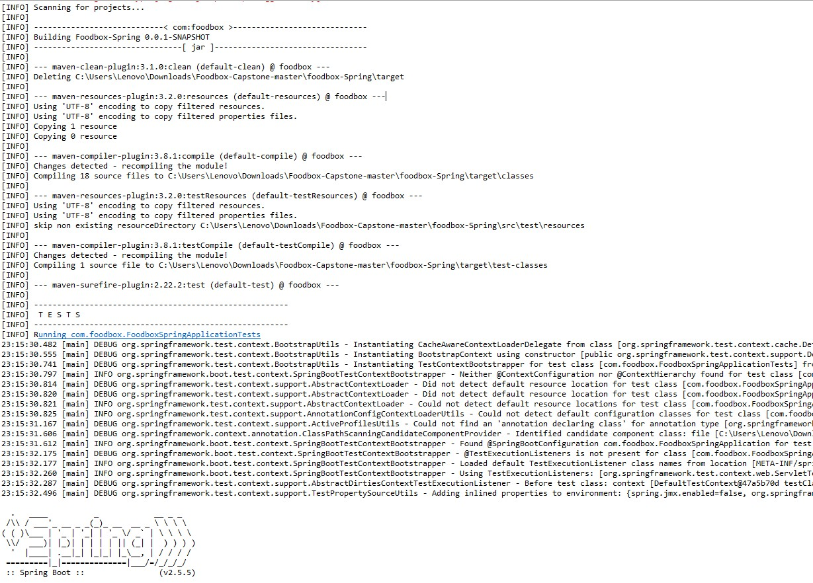

**(Front End Development)**

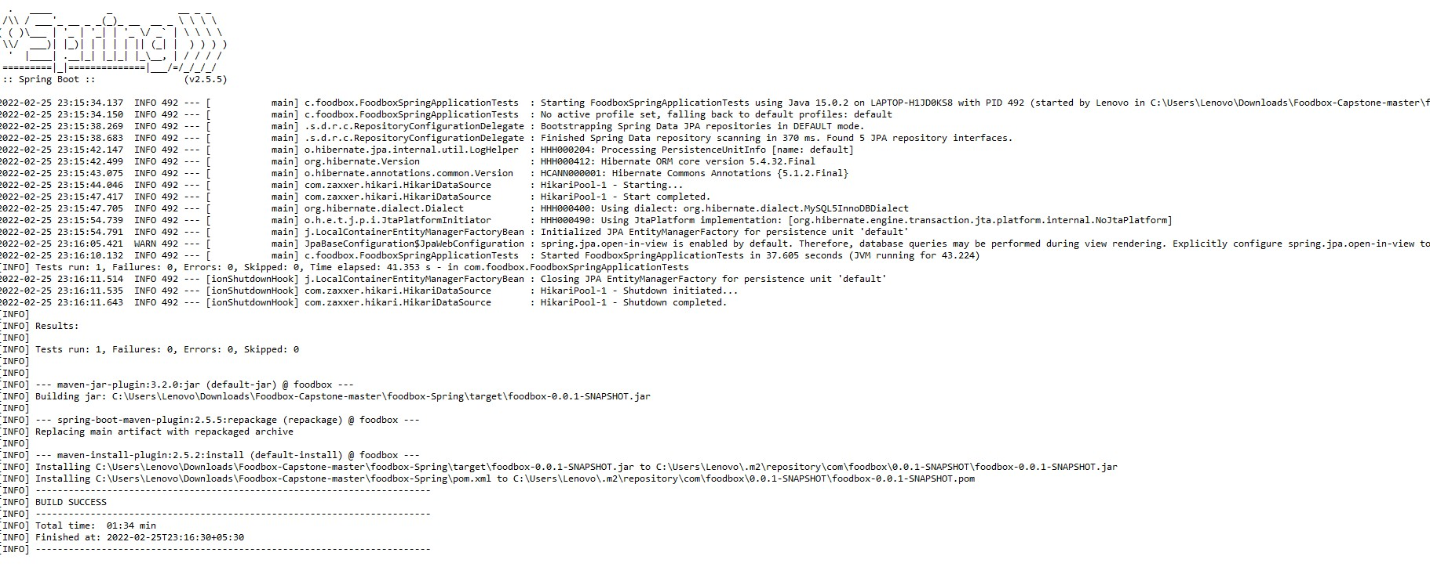

Angular Project Structure:

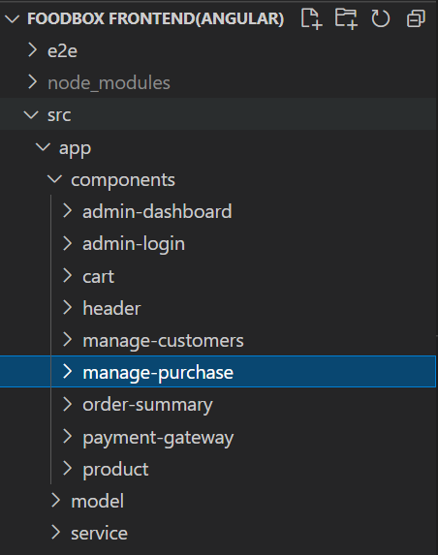

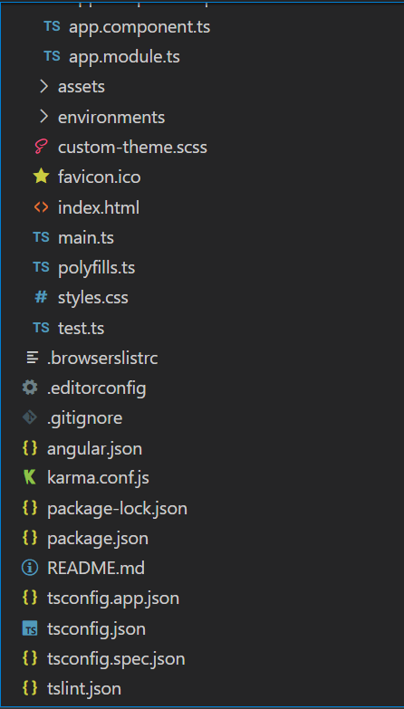

1. ***Project Files.***

Index.html

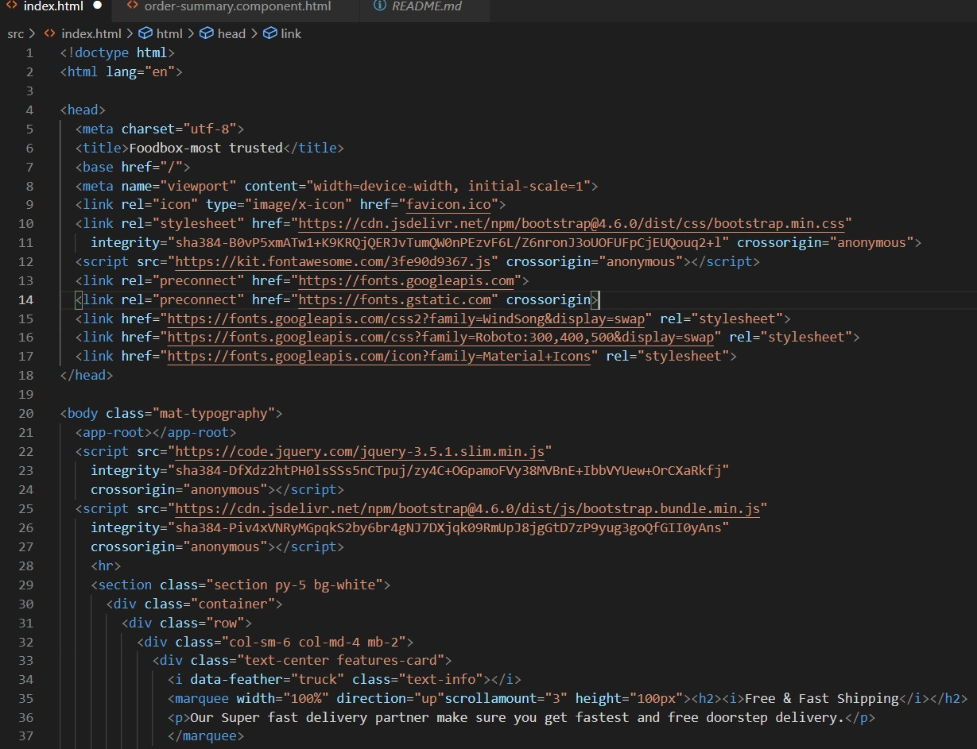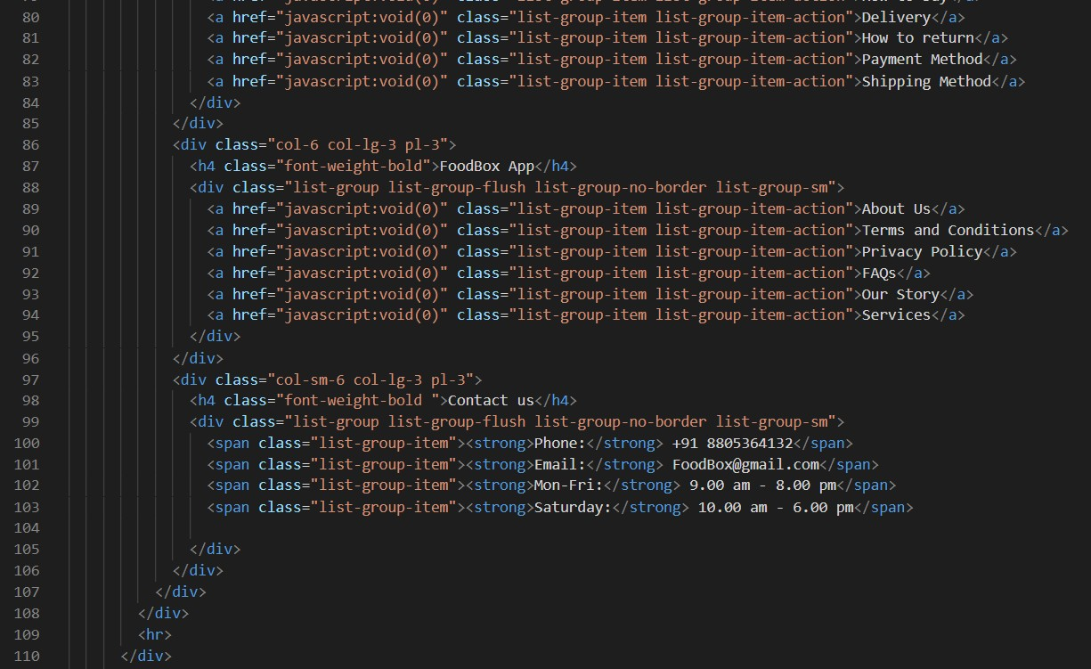

test.ts:

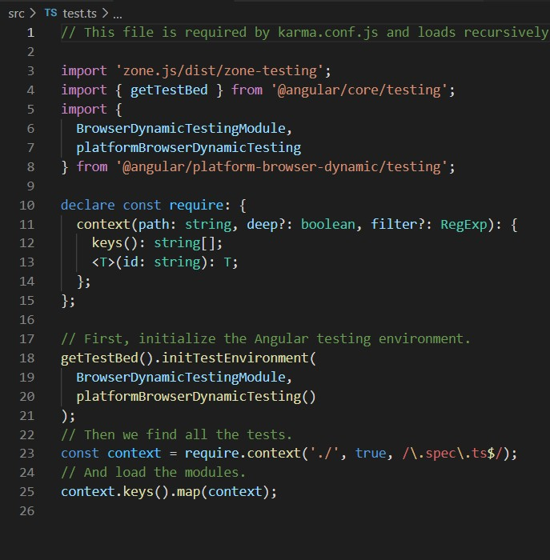

Rest of the files are present in the given GitHub link kindly refer this…

## <https://github.com/tuskhillare/FoodBox-Capstone-Project.git>

## Package.json:

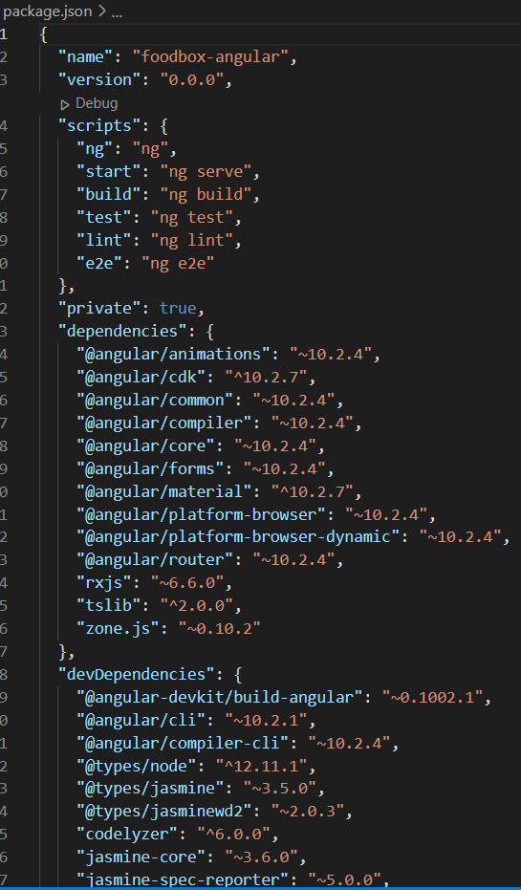

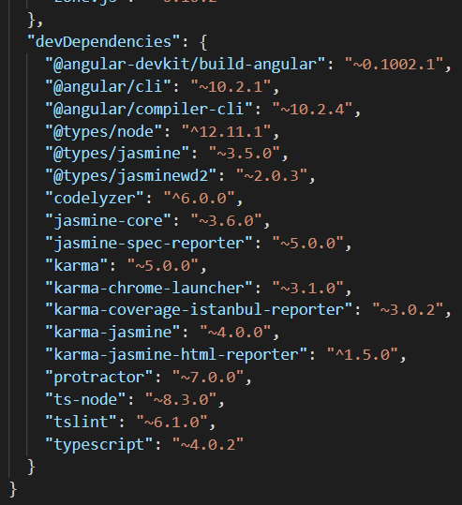

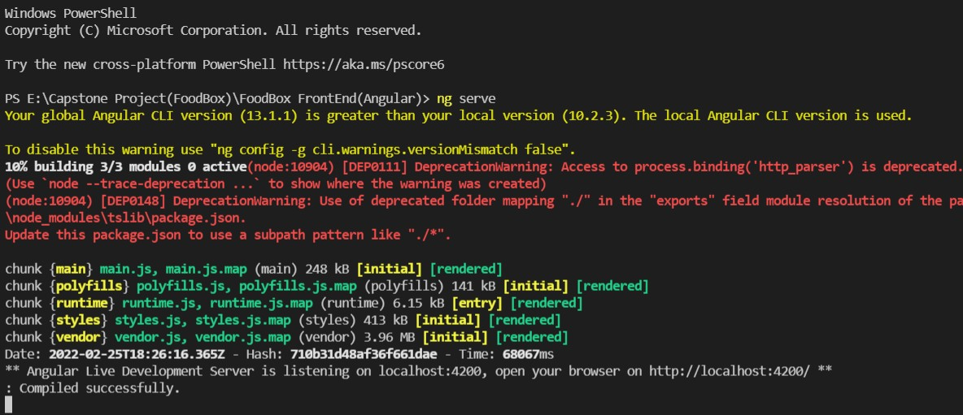Angular Outputs:

Thank You……………